# A Clear Finishing with Harbor Freight Nailer

There are many great nail gun-like tools out there and most of them do their work finely. The key fact is why choose a specific one like Harbor Freight? So, the answer can be passed through like this: harbor nail guns have a good remark on being the 3 in 1 nailer. This line will be described in the following sections.

## Key features of Harbor Freight Nailers

Harbor Freight tools have their dimension of fame for delivering great compatible stuff. One of the great nailers is supplied by them and the nailers have a satisfactory review always. Each special component of the nail guns will be cleared in the next portion.

### Weight

In terms of working with a nail gun and pressurized air pops it’s important to have a certain level of weight. And approximately most of the Harbor freight nailers come with 8-10-12 pounds. This is a lightweight measure but not one of the most lightweight guns.

Then again, this minimal weight gives an extra stance to work against the CFMs. Not forgetting to mention the fine grip that gives a great balance along with the weight. Ultimately it is not always a lightweight nailer to deal with.

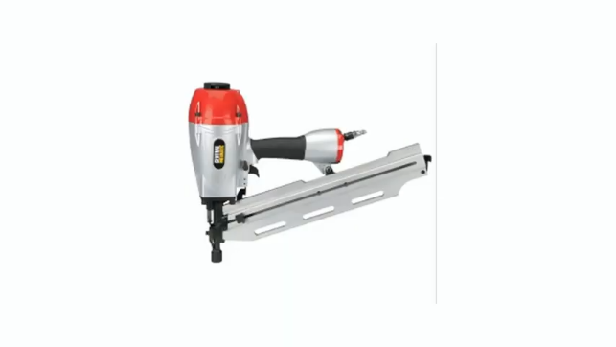 <https://www.youtube.com/watch?v=SFKoQMyN7nY>

### Nails and all about them

There are different angled nails in strips and not every gun is suitable to deal with all of them. Harbor freight’s some models do have 21°, 28°, 34° facilitated nail working adjustments. Often for this variant gauge angle flexibility, it is said to cover a 3 in 1 tool.

In each magazine of the nail gun, you can more or less fill 60-100 nails. And each strip of the nails consists of 25-26 nails. More importantly, the nail they use is round-headed nails.

The magazine has a pull off-on mechanism trigger that is pulled in when the magazine is loaded and pull out when is loaded the functionality is as easy as it's written. When it comes to nail, they are 2-3/8”- 3¾” and when popped they are nicely in the logs.

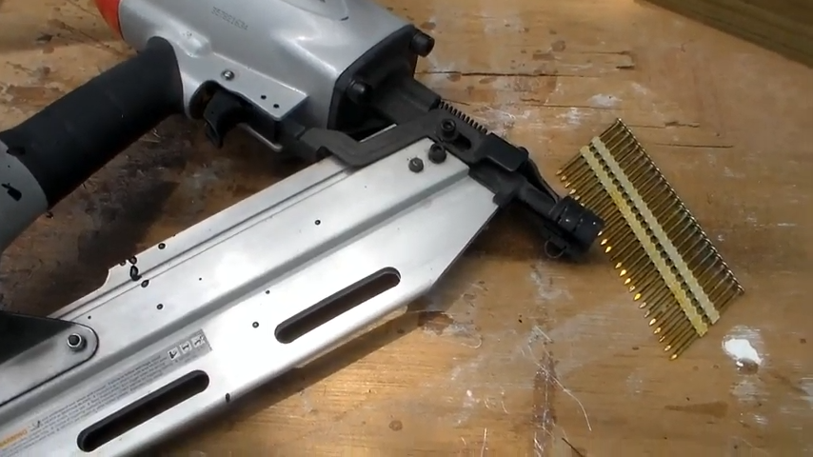

<https://www.youtube.com/watch?v=SFKoQMyN7nY>

### Hoses and pressures

The harbor freight framing nailers have a 360 rear hose adjustment which gives a better experience while working with the heavy models. A 20-gallon air compressor can have 95-100 psi for shooting the nails. And below an 8-gallon compressor, it will be hard to have a good outcome from the nailer.

## Harbor Freight covers 3 angles in 1 nailer

Generally, the magazines of a nailer are one-angled efficient and for a different angled gauge, you might switch to a different nail gun. In the central pneumatic model, Harbor freight has covered 21°, 28°, 34° magazine angle. This is certainly a great convention if you know how tough it is to deal with angular strips.

## Harbor Freight is not for professionals

If you are thinking of making your treehouse or render your dog’s house this can be a comparative great tool. Also, if your job for nailing is not that vital like remodeling the whole house and so then this is just not the stuff.

You see, this does have a good amount of weight and is also dependent on the hose and compressor, so it cannot be a freehand work handy. In these cases, you might go for a cordless, lighter weighted one.

## Modes of Harbor Freight nail guns

These nail guns work on two modes, that are single shots and bump drive. The single shots work one by one and are no bound of working in a row, just up to your choice and the bump is like a continuous shotgun.

Either way, the single shots give a better in of the nails whilst the bump mode has its drawbacks of giving an uneven push of the nails. The air pop needs to be fully covered if you want the nails to go full, and in the case of bump mode, it seems not working that way.

Also, there is a driving fire lockout mode, that enables to off the fire before all nail’s runout from the magazine. Almost when 3-4 nails are left the gun stops shooting. And the teeth like the front give an extra hold so the pops are better.

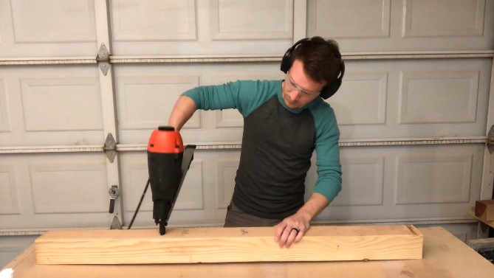 <https://www.youtube.com/watch?v=1kNzm6msZdU>

## Nail gauges for Harbor Freight

For the magazine, there are different angle customization. But in terms of working with the nail gauges, it has been noticed in the specifications, that the gauge size is between 10-15. The size of the gauges is a thin-like figure.

## FAQ

Can I do heavy-duty work with Harbor Freight nailers?

Even though they say this will give you the minimum fatigue but as you can see, they have a weight and the compressor hold, so this can be a little tiring for heavy-duty works.

Can I work with a 3-gallon compressor for harbor freight nailers?

It is recommended to have over 8-gallons for the compressor. The overall tool needs some minimal requirements and this is up to that. In that way, the air pressure will be with a good stance.

## Conclusion

Like many other nailers available in the market Harbor Freight is giving its fight to be one of the great ones. And surprisingly it has become a favorite one. The output of the final work is pretty neat with round-headed nails and it's visibly clear.

Maybe that is the reasoning for it to be good despite being not cordless and heavy. The rubbery body gives a better handle for the users and with a great stance comes a great outcome.